**How to access to the weekly labs in the Skillsoft environment**

Use the following steps to get to your weekly labs:

Step1: Go to Course Home then click on Course Resources to see Course Resources page.

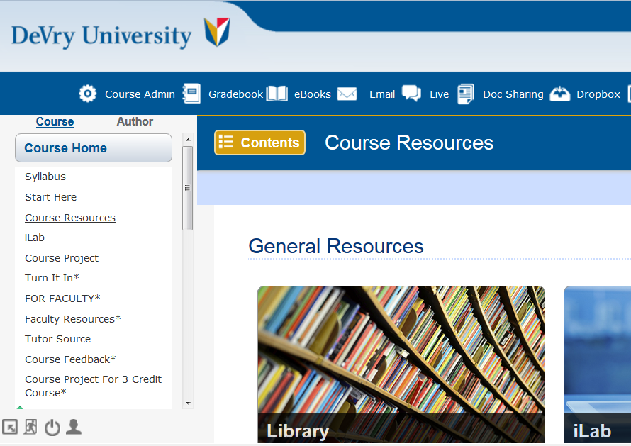

Step 2: Scroll down until you see the Virtual Lab-Skillsoft link:

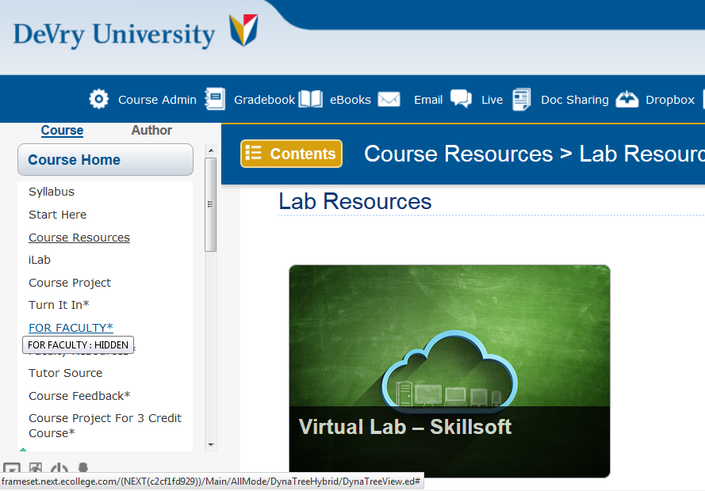

Step 3: Click on the Virtual Lab-Skillsoft link to see this page:

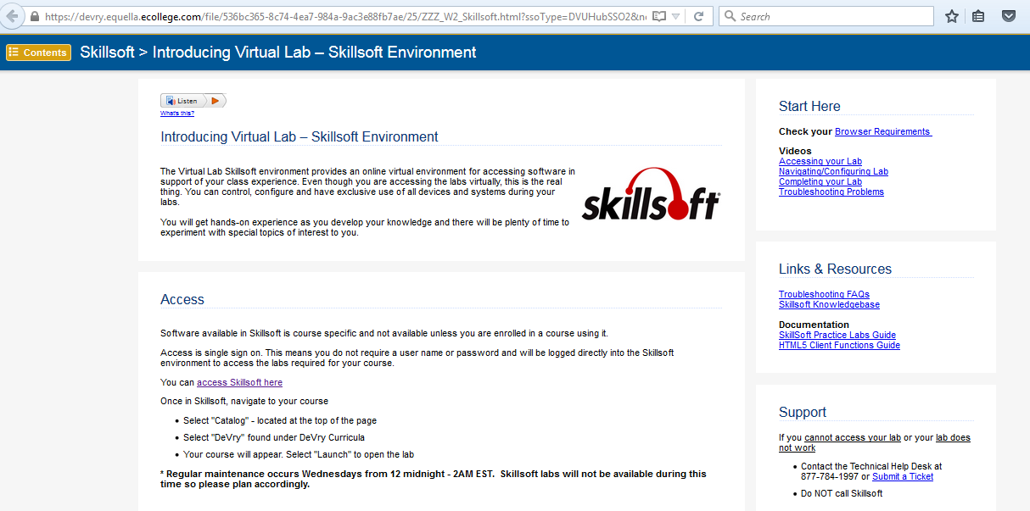

Step 4: Clicking on “access Skillsoft here” brings to the next page:

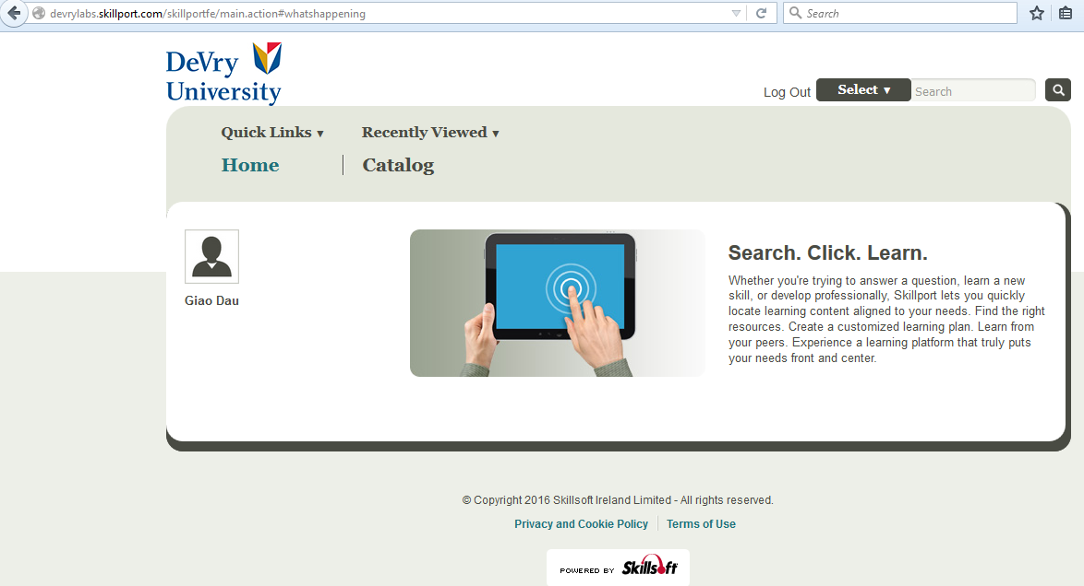

Step 5: Clicking on Catalog brings to the next page:

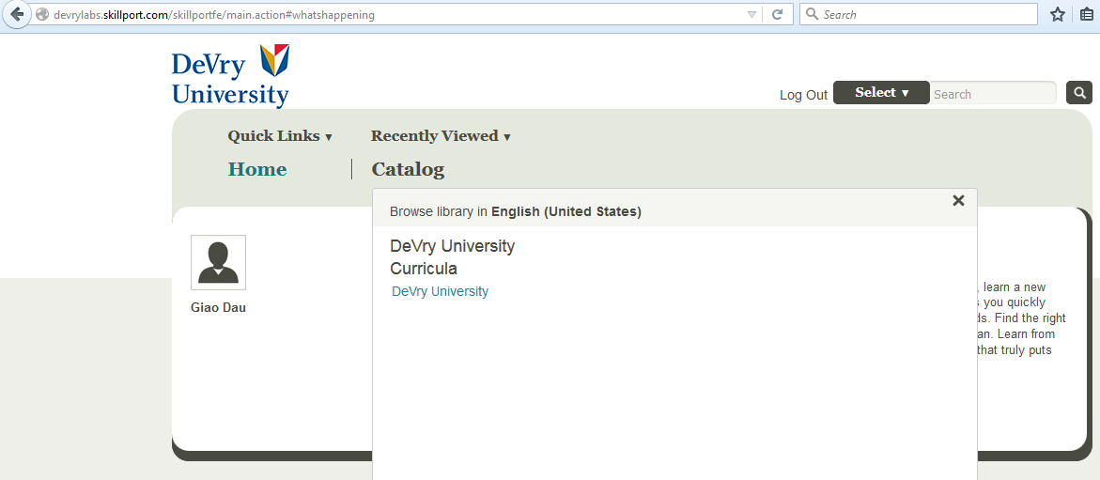

Step 6: Clicking on the Devry University link brings to the next page:

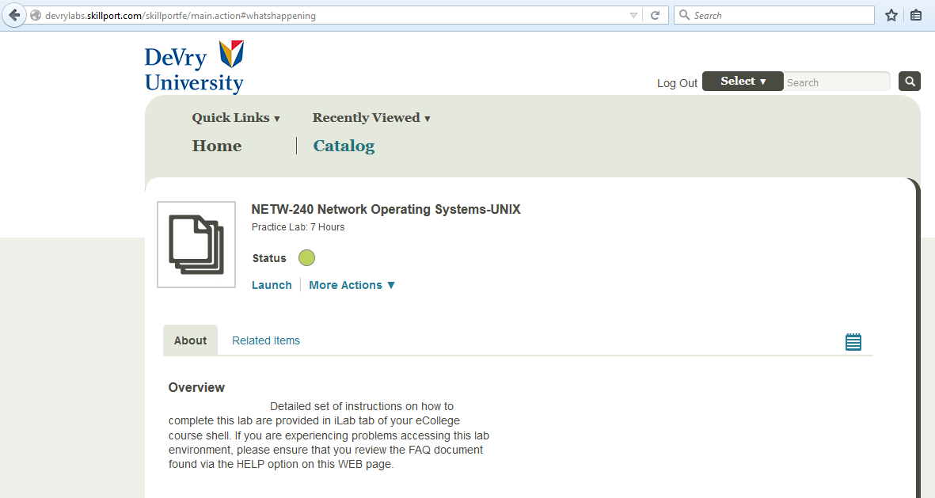

Step 7: Select your course if multiple courses are shown and click on Launch then scroll down to choose your lab.

